Buffalo Bannock Taco Sale Friday July 15, 2011 Hosted by Oasis Oskayak Girls Group
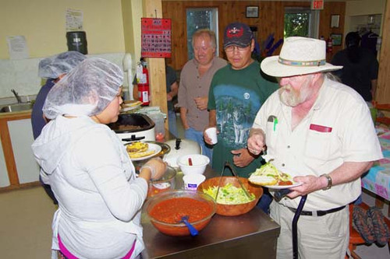
The Nipawin Oasis Centre held a buffalo bannock taco sale on Friday, July 15 to raise funds for the Oskayak Youth Group. Members of the youth group helped out with the preparation and serving.
Top of Form
Bottom of Form

